Mechatronics and Industrial Internet of Things

AUTOMATED COLOR – BASED PRODUCT SORTING SYSTEM FOR MANUFACTURING INDUSTRIES

PROJECT REPORT

BHAVESH PRAKASH G - 24MER005
VASANTHAN B – 24MER060
PRABHUKUMAR N – 24MER40
AJAY PRABHAV A – 24MER003
SANTHAKUMAR M – 24MEL065
DEEPAK C – 24MEL069

- Project Overview:
The Automated Color-Based Product Sorting System successfully demonstrates a basic industrial automation process using the ESP8266 NodeMCU, TCS3200 color sensor, servo motor, and LED indicators. The TCS3200 detects the color of a manually placed product, and the ESP8266 processes the sensor readings to identify whether the product is red or green. According to the reference document, the corresponding LED is activated and the servo motor moves to a predefined position to represent the sorting action. The prototype was able to perform the expected color detection and sorting response under controlled lighting conditions.
The system also demonstrates the potential for IoT-enabled smart manufacturing through the ESP8266's Wi-Fi connectivity. Sorting information such as detected color, product count, and sorting status can be transmitted to ThingSpeak for remote monitoring. The review of the prototype indicates that its performance mainly depends on sensor calibration, lighting conditions, sensor-to-product distance, and surface characteristics. Since a conveyor mechanism was not included, products were placed manually during testing. Overall, the project provides a practical foundation for automated product sorting and can be further developed into a complete smart manufacturing system.

- Project Statement:
In manufacturing industries, manual identification and sorting products based on their color can be time-consuming and may lead to human errors and inconsistent sorting. This can reduce production efficiency and increase the need for manual labor.
Therefore, there is a need for a low-cost automated system that can:
- Detect the color of products.
- Identify products based on predefined color categories.
- Provide visual indication of the detected color.
- Control a servo motor for the corresponding sorting action.
- Reduce manual effort and improve sorting consistency.
- Provide a foundation for future IoT-based monitoring and smart manufacturing applications.
The proposed system addresses these requirements using an ESP8266 NodeMCU, TCS3200 color sensor, servo motor, LED indicators, and ThingSpeak Cloud Service
- Proposed Solution:
The proposed solution is an Automated Color-Based Product Sorting System designed to automate the identification and sorting of products according to their color. The system uses a TCS3200 color sensor as the sensing element, an ESP8266 NodeMCU as the main controller, red and green LEDs for visual indication, and a servo motor as the sorting actuator. When a product is placed manually in front of the TCS3200 sensor, the sensor detects the reflected light from the product and produces frequency-based signals corresponding to the detected color. These signals are read by the ESP8266 and processed using predefined conditions to identify the product as red, green, or an invalid/undetected color.
Once the color is identified, the ESP8266 performs the corresponding sorting operation. For a red product, the red LED is switched ON and the servo motor rotates to a predefined position representing the red sorting direction. For a green product, the green LED is switched ON and the servo moves to the corresponding green sorting position. After the sorting movement, the servo returns to its center position so that the system is ready for the next product. When a valid color cannot be identified, the LEDs remain OFF and the servo stays at the center position. This process is continuously repeated for each product placed in front of the sensor.
The ESP8266 also provides Wi-Fi connectivity, allowing the system to be extended with IoT-based monitoring. Information such as the detected color, red and green product counts, total number of sorted products, and sorting status can be transmitted to ThingSpeak Cloud Service. The cloud platform can therefore be used to maintain production-related data and support remote observation of the sorting process. This provides a foundation for developing the prototype into a more advanced smart-manufacturing system with real-time production monitoring and data analysis.
In the present prototype, a conveyor mechanism is not included, so the products are placed manually in front of the sensor. The servo movement represents the mechanical diverter that would separate products into different collection areas in a complete industrial implementation. The effectiveness of the system depends on factors such as sensor calibration, lighting conditions, the distance between the sensor and product, and the surface and color characteristics of the product. Under suitable and controlled conditions, the prototype demonstrates the basic concept of automated color detection, classification, and sorting.

- System Architecture:

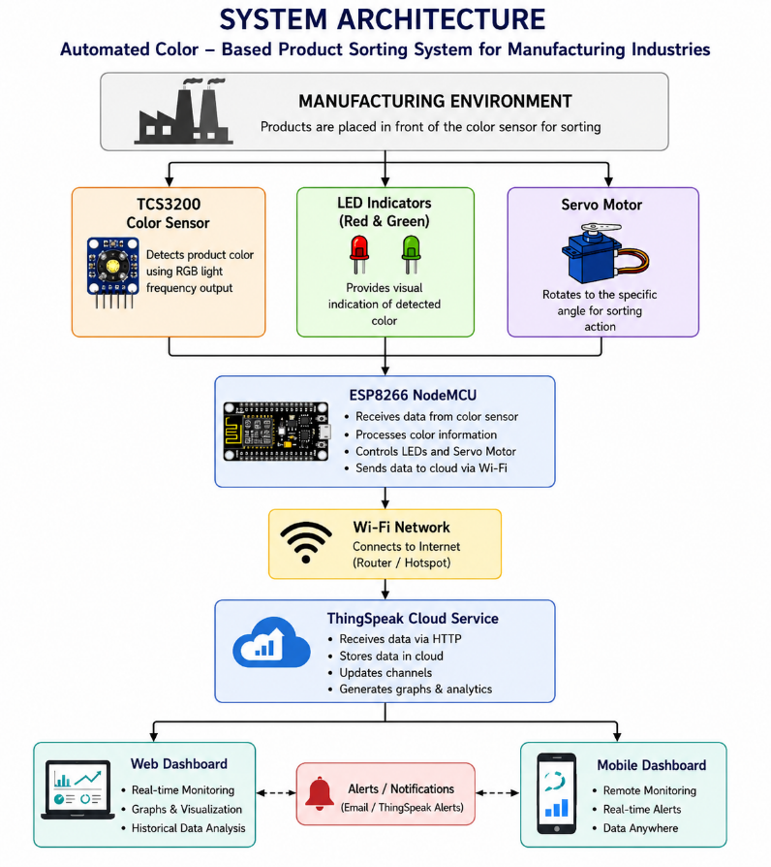

- Circuit Table:

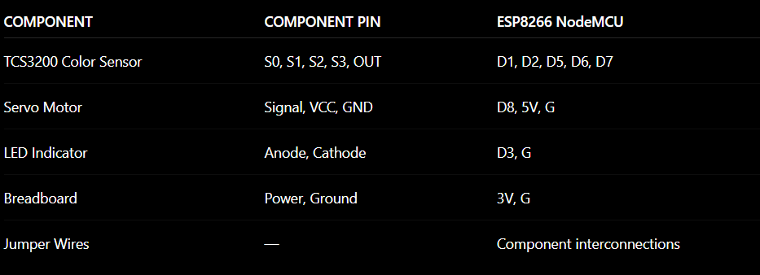

- Circuit Design:

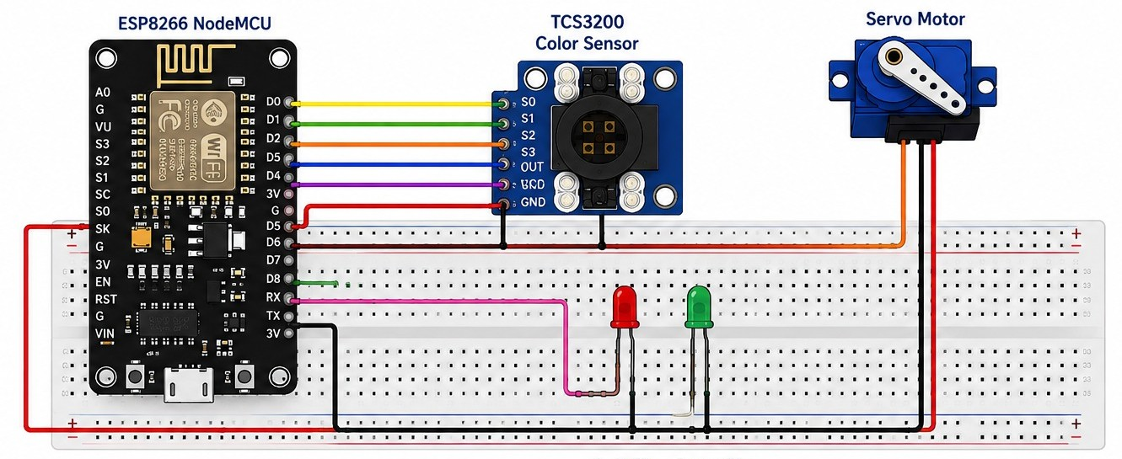

- Algorithm:
Step 1: Start the system.
Step 2: Initialize the ESP8266 NodeMCU, TCS3200 color sensor, LED indicator, and servo motor.
Step 3: Connect the ESP8266 to the configured Wi-Fi network.
Step 4: Place the product in front of the TCS3200 color sensor.
Step 5: Read the color values from the TCS3200 sensor.
Step 6: Process the sensor readings and identify the product color.
Step 7: Turn ON the corresponding LED indicator.
Step 8: Rotate the servo motor to the predefined sorting position.
Step 9: Return the servo motor to the center position.
Step 10: Send the detected color and sorting information to ThingSpeak Cloud.
Step 11: Repeat the process for the next product.

- Coding:
#include <Servo.h>
#include <ESP8266WiFi.h>
#include <ESP8266HTTPClient.h>
#include <WiFiClientSecure.h>

// =====================================================
// WIFI SETTINGS
// =====================================================

const char* WIFI_SSID = "P4";
const char* WIFI_PASSWORD = "1234567890";

// =====================================================
// THINGSPEAK WRITE API KEY
// =====================================================

const char* THINGSPEAK_API_KEY = "N59W7SM6U0LGRU23";

// =====================================================
// ESP8266 NODEMCU PIN ASSIGNMENTS
// =====================================================

// TCS3200
const int S0_PIN = 5; // D1
const int S1_PIN = 4; // D2
const int S2_PIN = 14; // D5
const int S3_PIN = 12; // D6
const int OUT_PIN = 13; // D7

// LEDs
const int RED_LED_PIN = 0; // D3
const int GREEN_LED_PIN = 2; // D4

// Servo
const int SERVO_PIN = 15; // D8

Servo sortingServo;

// =====================================================
// SERVO POSITIONS
// =====================================================

const int SERVO_CENTER = 90;
const int SERVO_RED = 30;
const int SERVO_GREEN = 150;

// =====================================================
// PRODUCT COUNTERS
// =====================================================

unsigned long redCount = 0;
unsigned long greenCount = 0;

// =====================================================
// DETECTED COLOR
//
// 0 = No valid color
// 1 = Red
// 2 = Green
// =====================================================

int detectedColor = 0;

// =====================================================
// THINGSPEAK UPDATE TIMER
// =====================================================

unsigned long lastThingSpeakUpdate = 0;

const unsigned long THINGSPEAK_INTERVAL = 15000;

// =====================================================
// READ TCS3200
// =====================================================

unsigned long readTCS3200(int s2State, int s3State)
{
digitalWrite(S2_PIN, s2State);
digitalWrite(S3_PIN, s3State);

delay(50);

unsigned long pulseWidth =
pulseIn(OUT_PIN, LOW, 100000);

return pulseWidth;
}

// =====================================================
// CONNECT TO WIFI
// =====================================================

void connectWiFi()
{
Serial.println();
Serial.print("Connecting to WiFi");

WiFi.begin(WIFI_SSID, WIFI_PASSWORD);

int attempts = 0;

while (WiFi.status() != WL_CONNECTED && attempts < 30)
{
delay(500);
Serial.print(".");
attempts++;
}

Serial.println();

if (WiFi.status() == WL_CONNECTED)
{
Serial.println("WiFi Connected!");

Serial.print("IP Address: ");
Serial.println(WiFi.localIP());
}
else
{
Serial.println("WiFi Connection Failed!");
}
}

// =====================================================
// SEND DATA TO THINGSPEAK
// =====================================================

void sendToThingSpeak()
{
// ---------------------------------------------------
// CHECK WIFI
// ---------------------------------------------------

if (WiFi.status() != WL_CONNECTED)
{
Serial.println("WiFi disconnected!");
connectWiFi();
}

if (WiFi.status() == WL_CONNECTED)
{
WiFiClientSecure client;

// For ESP8266 testing
client.setInsecure();

HTTPClient http;

// -------------------------------------------------
// CALCULATE TOTAL
// -------------------------------------------------

unsigned long totalSorted =
redCount + greenCount;

// -------------------------------------------------
// THINGSPEAK SERVER URL
// -------------------------------------------------

String url =
"https://api.thingspeak.com/update.json?api_key=";

url += THINGSPEAK_API_KEY;

// -------------------------------------------------
// FIELD 1
// 1 = RED
// 2 = GREEN
// -------------------------------------------------

url += "&field1=";
url += String(detectedColor);

// -------------------------------------------------
// FIELD 2
// RED COUNT
// -------------------------------------------------

url += "&field2=";
url += String(redCount);

// -------------------------------------------------
// FIELD 3
// GREEN COUNT
// -------------------------------------------------

url += "&field3=";
url += String(greenCount);

// -------------------------------------------------
// FIELD 4
// TOTAL SORTED
// -------------------------------------------------

url += "&field4=";
url += String(totalSorted);

// -------------------------------------------------
// SERIAL MONITOR
// -------------------------------------------------

Serial.println();
Serial.println("==============================");
Serial.println("THINGSPEAK UPDATE");
Serial.println("==============================");

Serial.print("Detected Color : ");
Serial.println(detectedColor);

Serial.print("Red Count : ");
Serial.println(redCount);

Serial.print("Green Count : ");
Serial.println(greenCount);

Serial.print("Total Sorted : ");
Serial.println(totalSorted);

Serial.println();
Serial.println("Connecting to ThingSpeak...");

// -------------------------------------------------
// HTTP REQUEST
// -------------------------------------------------

if (http.begin(client, url))
{
int httpCode = http.GET();

// ------------------------------------------------
// SERVER RESPONSE
// ------------------------------------------------

Serial.print("HTTP Response Code: ");
Serial.println(httpCode);

if (httpCode > 0)
{
String response =
http.getString();

Serial.print("ThingSpeak Response: ");
Serial.println(response);

// ----------------------------------------------
// SUCCESS
// ----------------------------------------------

if (response.indexOf("\"entry_id\"") >= 0)
{
Serial.println();
Serial.println(
">>> THINGSPEAK UPDATE SUCCESSFUL <<<"
);
}
else if (response == "0")
{
Serial.println();
Serial.println(
">>> THINGSPEAK UPDATE FAILED <<<"
);
Serial.println(
"Check Write API Key and Channel."
);
}
else
{
Serial.println(
"ThingSpeak returned a response."
);
}
}
else
{
Serial.print("HTTP Error: ");
Serial.println(
http.errorToString(httpCode)
);
}

http.end();
}
else
{
Serial.println(
"Unable to connect to ThingSpeak server!"
);
}

Serial.println("==============================");
}
}

// =====================================================
// SETUP
// =====================================================

void setup()
{
Serial.begin(115200);

// ===================================================
// TCS3200
// ===================================================

pinMode(S0_PIN, OUTPUT);
pinMode(S1_PIN, OUTPUT);

pinMode(S2_PIN, OUTPUT);
pinMode(S3_PIN, OUTPUT);

pinMode(OUT_PIN, INPUT);

// ===================================================
// LEDs
// ===================================================

pinMode(RED_LED_PIN, OUTPUT);
pinMode(GREEN_LED_PIN, OUTPUT);

digitalWrite(RED_LED_PIN, LOW);
digitalWrite(GREEN_LED_PIN, LOW);

// ===================================================
// TCS3200 FREQUENCY SCALING
// ===================================================

digitalWrite(S0_PIN, HIGH);
digitalWrite(S1_PIN, LOW);

// ===================================================
// SERVO
// ===================================================

sortingServo.attach(SERVO_PIN);

sortingServo.write(SERVO_CENTER);

delay(1000);

// ===================================================
// WIFI
// ===================================================

connectWiFi();

// ===================================================
// STARTUP MESSAGE
// ===================================================

Serial.println();
Serial.println("==============================");
Serial.println(" AUTOMATED COLOR SORTING");
Serial.println("==============================");
Serial.println("TCS3200 : READY");
Serial.println("Servo : READY");
Serial.println("WiFi : READY");
Serial.println("ThingSpeak : READY");
Serial.println("==============================");
Serial.println("SYSTEM READY");
Serial.println();

// ===================================================
// INITIAL THINGSPEAK TEST
// ===================================================

if (WiFi.status() == WL_CONNECTED)
{
Serial.println("Testing ThingSpeak connection...");

sendToThingSpeak();

lastThingSpeakUpdate = millis();
}
}

// =====================================================
// MAIN LOOP
// =====================================================

void loop()
{
unsigned long red;
unsigned long green;

// ===================================================
// READ RED
// S2 = LOW
// S3 = LOW
// ===================================================

red = readTCS3200(LOW, LOW);

// ===================================================
// READ GREEN
// S2 = HIGH
// S3 = HIGH
// ===================================================

green = readTCS3200(HIGH, HIGH);

// ===================================================
// DISPLAY SENSOR VALUES
// ===================================================

Serial.println("------------------------------");

Serial.print("RED = ");
Serial.println(red);

Serial.print("GREEN = ");
Serial.println(green);

// ===================================================
// INVALID SENSOR READING
// ===================================================

if (red == 0 || green == 0)
{
Serial.println("No valid sensor reading");

detectedColor = 0;

digitalWrite(RED_LED_PIN, LOW);
digitalWrite(GREEN_LED_PIN, LOW);

sortingServo.write(SERVO_CENTER);

delay(500);
}

// ===================================================
// RED OBJECT
// ===================================================

else if (red < green)
{
Serial.println("RED OBJECT DETECTED");

detectedColor = 1;

redCount++;

// Red LED
digitalWrite(RED_LED_PIN, HIGH);
digitalWrite(GREEN_LED_PIN, LOW);

// Servo → Red position
sortingServo.write(SERVO_RED);

delay(1000);

// Servo → Center
sortingServo.write(SERVO_CENTER);

delay(500);
}

// ===================================================
// GREEN OBJECT
// ===================================================

else if (green < red)
{
Serial.println("GREEN OBJECT DETECTED");

detectedColor = 2;

greenCount++;

// Green LED
digitalWrite(RED_LED_PIN, LOW);
digitalWrite(GREEN_LED_PIN, HIGH);

// Servo → Green position
sortingServo.write(SERVO_GREEN);

delay(1000);

// Servo → Center
sortingServo.write(SERVO_CENTER);

delay(500);
}

// ===================================================
// EQUAL VALUES
// ===================================================

else
{
Serial.println("COLOR NOT DETECTED");

detectedColor = 0;

digitalWrite(RED_LED_PIN, LOW);
digitalWrite(GREEN_LED_PIN, LOW);

sortingServo.write(SERVO_CENTER);

delay(500);
}

// ===================================================
// THINGSPEAK UPDATE EVERY 15 SECONDS
// ===================================================

if (millis() - lastThingSpeakUpdate >=
THINGSPEAK_INTERVAL)
{
Serial.println();
Serial.println(
"Uploading data to ThingSpeak..."
);

sendToThingSpeak();

lastThingSpeakUpdate = millis();
}
}

- System Working:

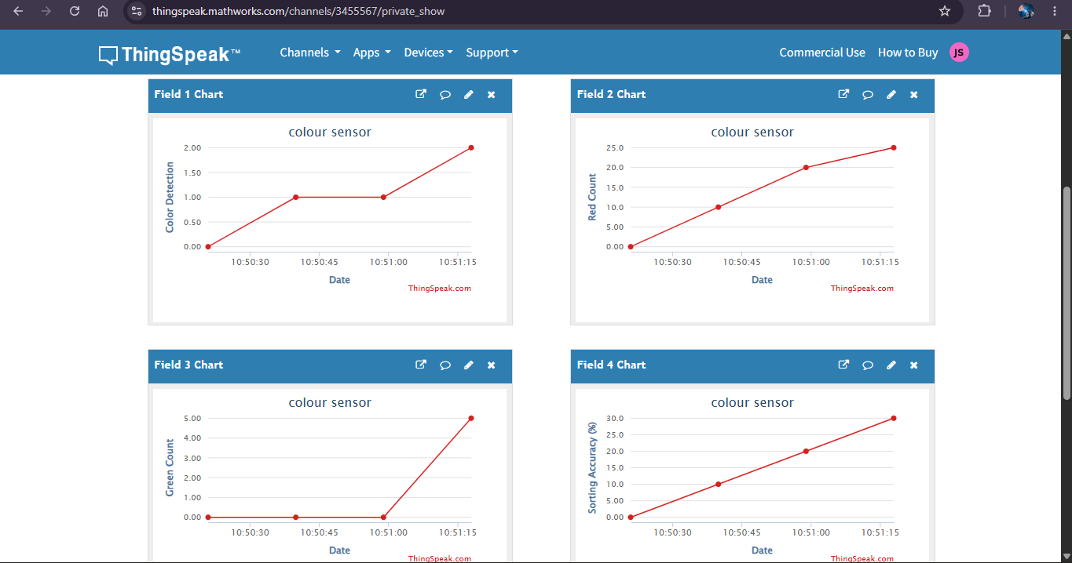

- Working sequence:
Product Placement → Color Detection by TCS3200 → ESP8266 Processing → Color Identification → LED Indication → Servo Movement → Sorting Action → Servo Returns to Center → ThingSpeak Data Transmission → Repeat.

- Bill of Materials:
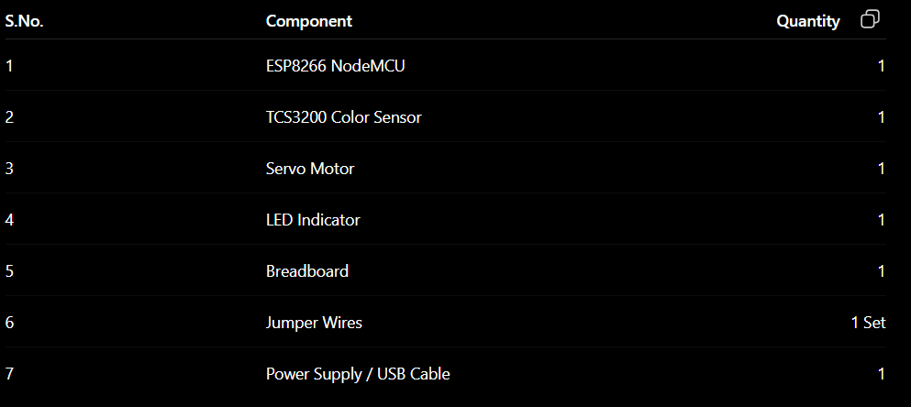

- Prototype Implementation:

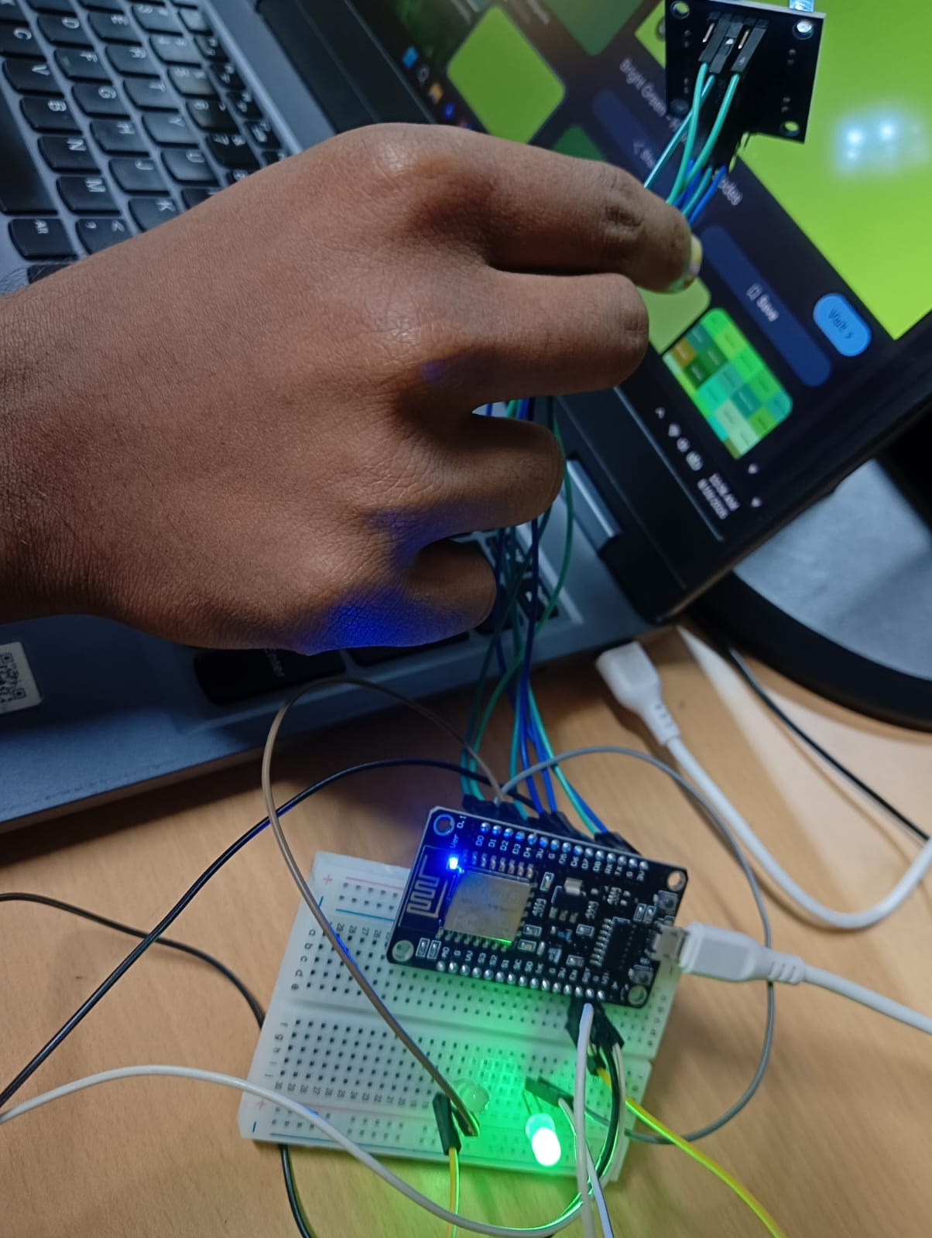

- Results and Performance Analysis:
Performance:
The system provides:
- Automatic detection of product color using the TCS3200 sensor.
- Real-time processing using ESP8266 NodeMCU.
- Visual indication through the LED indicator.
- Servo-based sorting action according to the detected color.
- Wireless connectivity through ESP8266.
- ThingSpeak-based monitoring of detected color and sorting information.
- Consistent operation under controlled lighting conditions.

Advantages:
- Low-cost implementation.
- Simple circuit design.
- Reduces manual sorting effort.
- Provides faster and more consistent color-based sorting.
- Wireless monitoring is possible through ESP8266.
- Can be integrated with ThingSpeak for remote monitoring.
- Can be expanded into a complete smart manufacturing system.
Limitations:
- Color detection accuracy depends on sensor calibration.
- Lighting conditions can affect the sensor readings.
- Detection depends on the distance between the sensor and the product.
- Product surface characteristics and color can affect the results.

